15. ReactJS-HOL

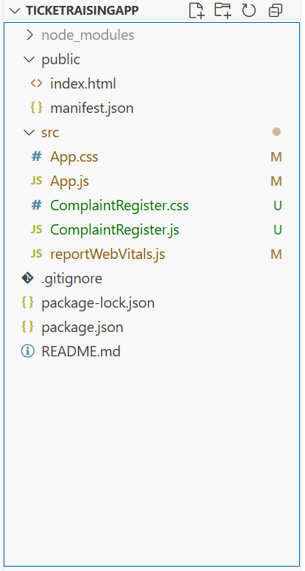

ComplaintRegister.js
import React, { Component } from 'react';
class ComplaintRegister extends Component {
constructor(props) {
super(props);
this.state = {
ename: '',
complaint: '',
NumberHolder: Math.floor(Math.random() * 100) // Initial reference number
};
}

handleChange = (event) => {
this.setState({ [event.target.name]: event.target.value });
};

handleSubmit = (event) => {
event.preventDefault();
const refNo = Math.floor(Math.random() * 1000);
this.setState({ NumberHolder: refNo });

const msg = `Thanks ${this.state.ename}\nYour Complaint was Submitted.\nTransaction ID is: ${refNo}`;
alert(msg);
};
render() {
return (
<div>
<label>Name: </label>
<input
type="text"
name="ename"
value={this.state.ename}
onChange={this.handleChange}
required
/>
</div>
<br />
<div>
<label>Complaint: </label>
<textarea
name="complaint"
value={this.state.complaint}
onChange={this.handleChange}
required
/>
</div>
<br />
<button type="submit">Submit</button>
</form>
</div>
);
}
}
export default ComplaintRegister;

App.js
import React from 'react';
import ComplaintRegister from './ComplaintRegister';

function App() {
return (
<div className="App">
<ComplaintRegister />
</div>
);
}
export default App;
